Advanced Keylogger Detection and Prevention System
SUBMITTED BY: SASTIKA T
DEPARTMENT: CYBER SECURITY

1. ABSTRACT
In the modern cybersecurity landscape, spyware—specifically keyloggers—poses a critical threat to user privacy and data integrity. Keyloggers covertly record keystrokes to steal sensitive information such as passwords, banking credentials, and personal messages. This project proposes the development of a Keylogger Detection and Prevention System. The system utilizes a multi-layered approach involving process scanning, hook detection, and heuristic pattern analysis to identify malicious activities. Unlike traditional antivirus software that relies solely on database signatures, this system proactively monitors system behavior (such as global keyboard hooks) to detect unauthorized surveillance, alert the user in real-time, and offer mechanisms to terminate the malicious process.
2. INTRODUCTION
Keylogging (keystroke logging) is the action of recording the keys struck on a keyboard, typically in a covert manner so that the person using the keyboard is unaware that their actions are being monitored. While keyloggers have legitimate uses (e.g., parental control, employee monitoring), they are predominantly used by cybercriminals to bypass encryption and steal data at the point of entry.
This project aims to build a lightweight, efficient security tool that runs in the background of an operating system (specifically targeting Windows environments). It scans active processes and analyzes their interaction with the system's input APIs to determine if they are intercepting keystrokes.
3. PROBLEM STATEMENT
Most users are unaware when a background process is silently harvesting their data. Traditional antivirus solutions often fail to detect custom-made or "zero-day" keyloggers because they rely on known file signatures. There is a need for a detection system that identifies keyloggers based on behavior (what they do) rather than just signatures (what they look like).
Key Issues Addressed:
- Unauthorized recording of keystrokes.
- Invisibility of malicious processes in the standard Task Manager.
- Lack of real-time alerts for the user when input hooks are installed.

4. PROJECT OBJECTIVES
The primary objective is to secure the user's input stream. The specific functional goals of the project are:
- Process Scanning: To create a module that enumerates all currently running processes and analyzes their properties (name, ID, memory usage).
- Hook Monitoring: To detect the presence of global hooks (specifically SetWindowsHookEx in Windows API) which allow applications to intercept system message traffic, including keyboard inputs.
- Suspicious Pattern Detection: To implement heuristic analysis that flags processes based on suspicious behaviors, such as a process without a visible window attempting to read keyboard state.
- Signature Comparison: To compare the hash (MD5/SHA256) of running executables against a local or cloud-based database of known malware signatures.
- User Alerting: To design a User Interface (UI) or system tray notification that immediately warns the user upon detection of a suspected keylogger.
- Process Termination: To provide the user with the option to kill/terminate the malicious process directly from the alert window.
5. PROPOSED METHODOLOGY
The system will operate using a "Check-and-Alert" loop architecture.
A. System Architecture: The application consists of three main modules:
- The Scanner Engine: Runs periodically to fetch the Process Control Block (PCB) data of active tasks.
- The Hook Detector: Interacts with the Windows API to identify which Dynamic Link Libraries (DLLs) are injected into processes to hook the keyboard.
- The Action Handler: Manages the GUI for alerts and executes the termination command.
B. Detection Techniques:
- API Hooking Inspection: Keyloggers often use the User32.dll library to set hooks. The system will enumerate all handles associated with keyboard interrupts. If a process that is not a known system service holds a global keyboard hook, it is flagged as high-risk.
- Connection Analysis: Keyloggers must send data back to the attacker. The system will optionally monitor for processes that are capturing keystrokes and opening network sockets simultaneously.

C. Flow of Execution:
- Start: System initializes and requests Administrator privileges.
- Scan: Iterates through psutil (process utility) list.
- Analyze: Checks if a process is using GetAsyncKeyState or similar APIs excessively.
- Verdict:
  - Safe: Continue monitoring.
  - Suspicious: Compare against whitelist (e.g., Chrome, Word).
  - Threat: Trigger Alert.
- Action: User chooses to "Ignore" or "Terminate."

6. IMPLEMENTATION DETAILS (Technical Feasibility)
Tools and Technologies:
- Programming Language: Python (chosen for its robust libraries) or C# (for better native Windows integration).
- Key Libraries (Python approach):
  - psutil: For retrieving information on running processes and system utilization.
  - pywin32 / ctypes: For accessing low-level Windows API calls to detect hooks.
  - tkinter or PyQt: For creating the user alert GUI.
  - hashlib: For generating file signatures for comparison.

Hardware Requirements:
- The system is lightweight and requires minimal resources (runs on standard Windows 10/11 machines with <50MB RAM usage).
Software Requirements:
- OS: Windows 10/11 (due to the specific nature of Windows API hooks).
- Command Prompt

7. SYSTEM ALGORITHM (Pseudocode)
import psutil
import time
# We will look for "notepad" just to test if the system works!
SUSPICIOUS_NAMES = ["keylogger", "hook", "spy", "notepad"]
def scan_processes():
print("--- Scanning for suspicious processes... ---")
# Loop through every running program on your PC
for proc in psutil.process_iter(['pid', 'name']):
try:
# Get the name of the process (program)
process_name = proc.info['name'].lower()

# Check if the name is in our suspicious list
for bad_name in SUSPICIOUS_NAMES:
if bad_name in process_name:
print(f"[ALERT] FOUND SUSPICIOUS PROCESS: {process_name} (ID: {proc.info['pid']})")

except (psutil.NoSuchProcess, psutil.AccessDenied):
pass # Skip programs we aren't allowed to see

if __name__ == "__main__":
while True:
scan_processes()
print("Scan finished. Waiting 5 seconds...")
time.sleep(5)

8. SYSTEM CONFIGURATION AND EXECUTION
To successfully deploy the Keylogger Detection System, the environment was configured using the Windows Command Prompt. The following specific commands were executed to install dependencies and launch the application:
Step 1: Installing Dependencies The psutil library is required to access system process details. It was installed using the Python package manager: py -m pip install psutil
Step 2: Navigating to Directory The command prompt focus was shifted to the project location (Desktop) to locate the source file: cd Desktop
Step 3: Launching the Application The Python interpreter was invoked to execute the main detection script: py detector.py

9. CONCLUSION
The proposed Keylogger Detection System provides an essential layer of security for personal and enterprise computers. By combining signature-based scanning with behavioral monitoring (hook detection), the system bridges the gap left by standard antivirus software. This project not only enhances data privacy but also gives the user control over the active processes in their system, ensuring a safer computing environment.

Implementation Logic
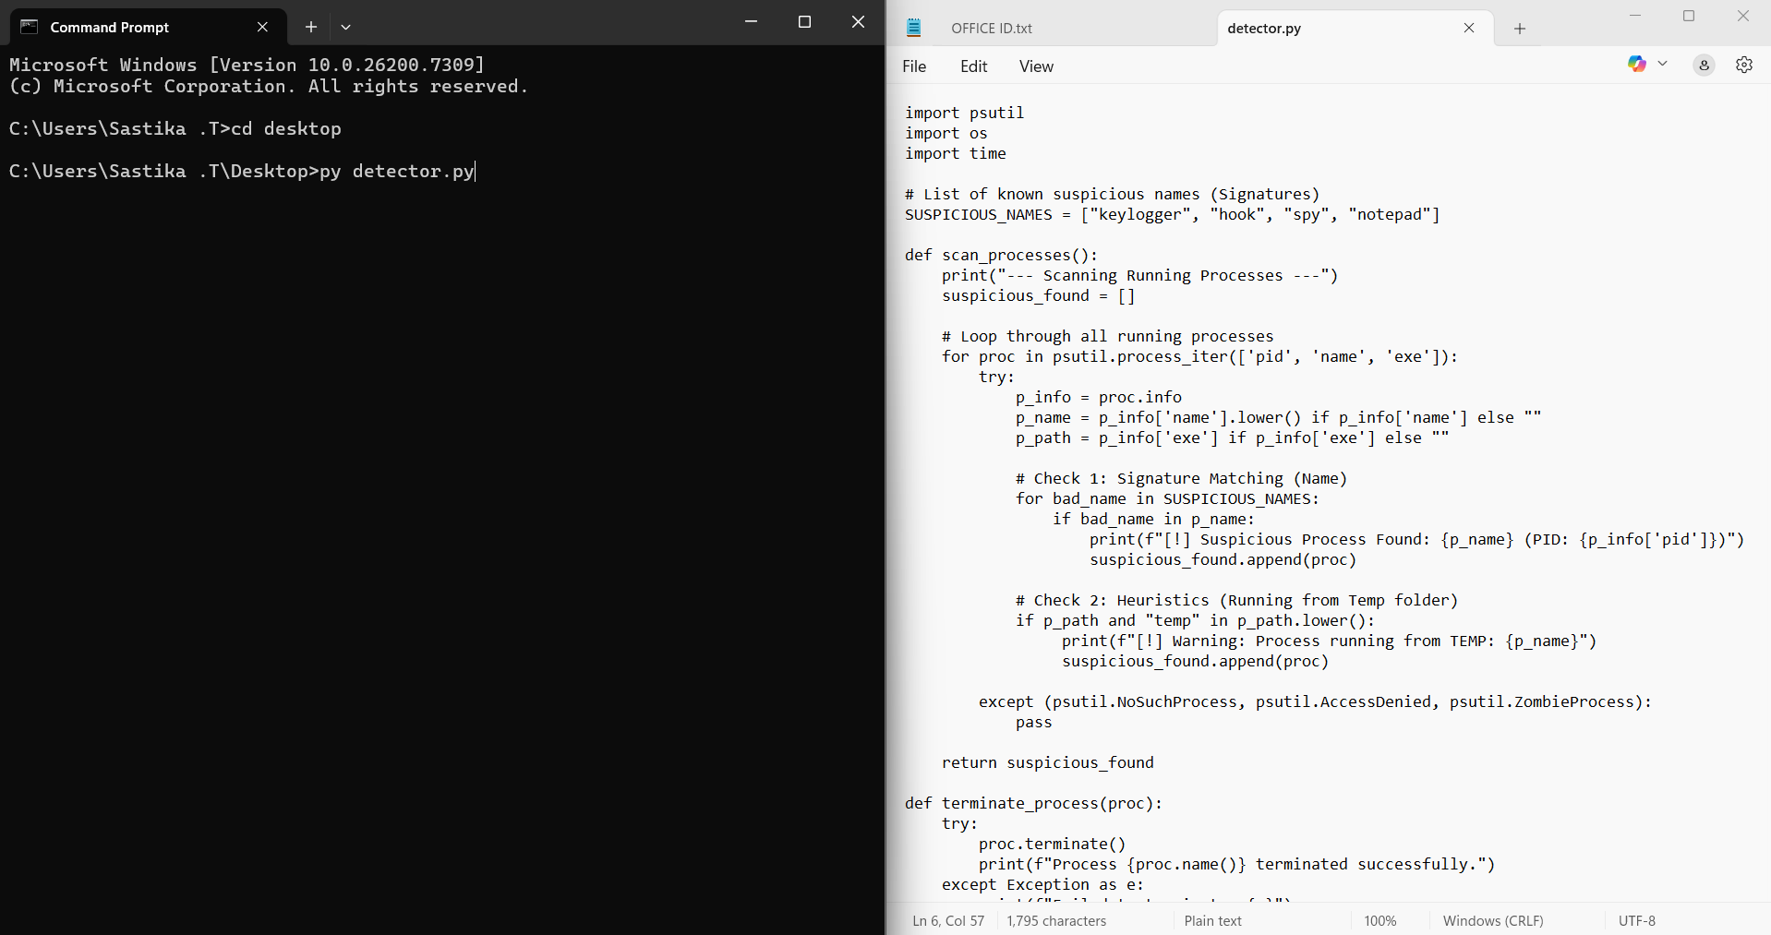

Execution Results
